**Name:** Waleed Amjad

**Roll No:** 2023-BS-Ai-054

**Department:** AI

**Sec:** A

**Semester:** 3rd

***Home Assignment***



**Program 1(Marks):**

**Code:**

#include <iostream>

#include <vector>

using namespace std;

int main() {

vector<string> Subject = {"Dsa=80", "Eng=90", "Calculus=98", "THQ=100", "Ai=50", "SE=85"};

for (int i = 0; i < Subject.size(); i++) {

cout << Subject[i] << endl;

}

return 0;

}

**Ouput:**

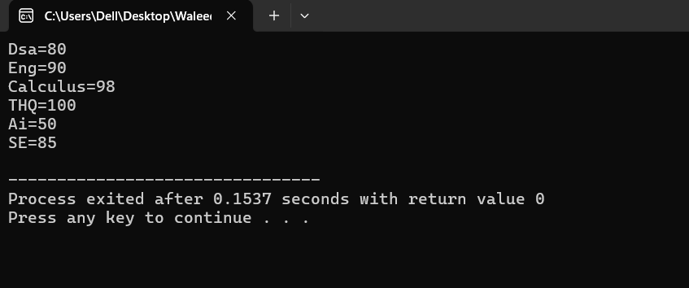

**Program 2(Sum of numbers):**

**Code:**

#include <iostream>

#include <vector>

using namespace std;

int main() {

vector<int> numbers;

int num, sum = 0;

cout << "Enter numbers (type -1 to stop):" << endl;

while (true) {

cin >> num;

if (num == -1) {

break;

}

numbers.push_back(num);

}

for (int number : numbers) {

sum += number;

}

cout << "The sum of the numbers is: " << sum << endl;

return 0;

}

**Output:**

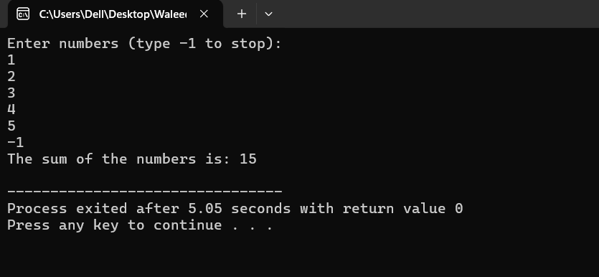

**Program 3(Multiplication of numbers):**

**Code:**

#include <iostream>

#include <vector>

using namespace std;

int main() {

vector<int> numbers;

int num;

long long product = 1; // Initialize product to 1

cout << "Enter numbers (type -1 to stop):" << endl;

while (true) {

cin >> num;

if (num == -1) {

break;

}

numbers.push_back(num);

}

for (int number : numbers) {

product *= number; // Multiply each number

}

cout << "The product of the numbers is: " << product << endl;

return 0;

}

**Output:**

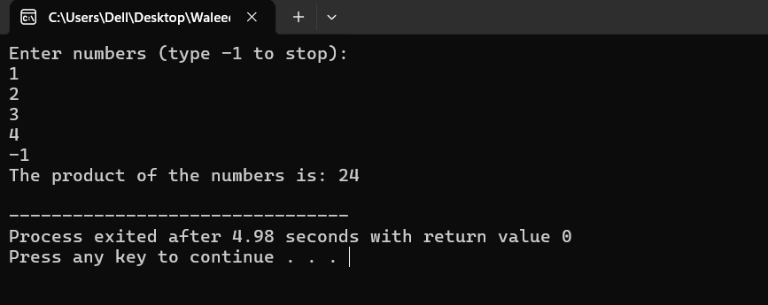

**Program 4(push and pop):**

**Code:**

#include <iostream>

#include <vector>

using namespace std;

int main(){

vector<int> numbers;

float input;

cout<<"Enter any numbers: "<<endl;

for(int i=0;i<5;i++){

cin>>input;

numbers.push_back(input);

}

cout<<"\n You have entered the following numbers: "<<endl;

for(int i=0;i<numbers.size();i++){

cout<<numbers[i]<<" "<<endl;

}

//remove a number

numbers.pop_back();

// Display the modified vector

cout << "Modified vector after pop_back(): ";

for (int num : numbers) {

cout << num << " ";

}

cout << endl;

return 0;

}

**Output:**

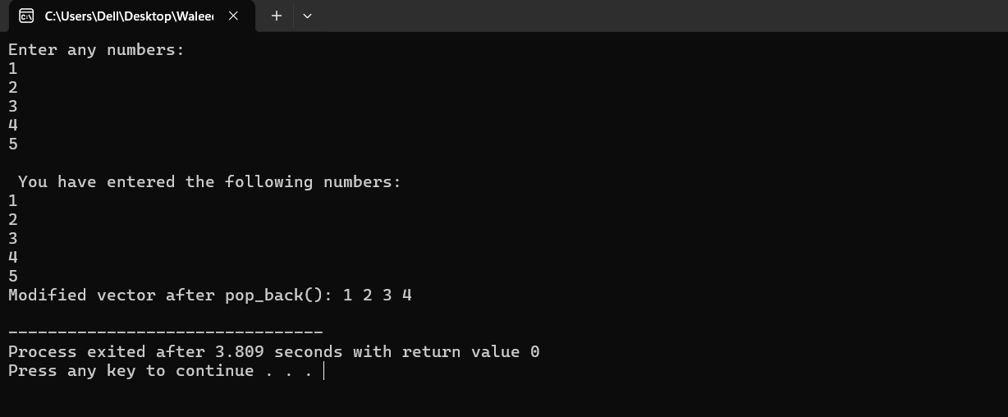

**Program 5(To do list):**

**Code:**

#include <iostream>

#include <vector>

using namespace std;

int main() {

const int maxTasks = 5;

string tasks[maxTasks];

vector<bool> taskStatus;

int taskCount = 0;

char choice;

do {

if (taskCount < maxTasks) {

cout << "Enter task description: ";

cin.ignore();

getline(cin, tasks[taskCount]);

taskStatus.push_back(false);

taskCount++;

cout << "Task added successfully!" << endl;

} else {

cout << "Task list is full!" << endl;

}

cout << "Do you want to add another task? (y/n): ";

cin >> choice;

} while (choice == 'y' && taskCount < maxTasks);

cout << "\nTo-Do List:" << endl;

for (int i = 0; i < taskCount; i++) {

cout << i + 1 << ". " << tasks[i] << " [";

if (taskStatus[i]) {

cout << "Completed";

} else {

cout << "Not Completed";

}

cout << "]" << endl;

}

return 0;

}

**Output:**

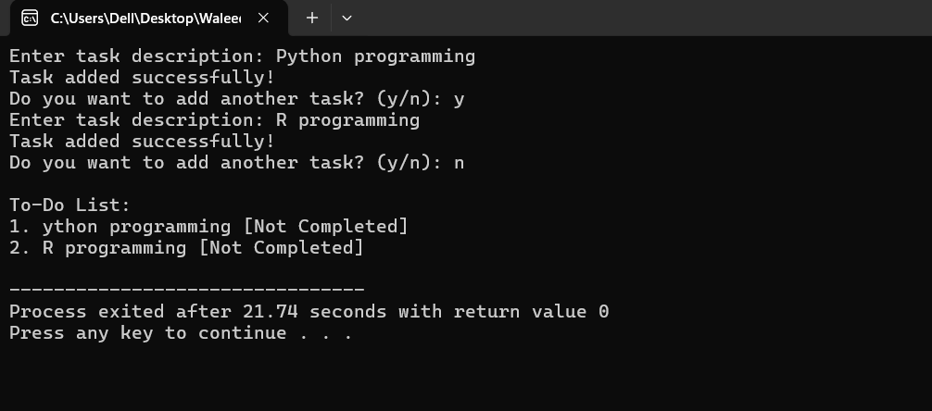

***End of Assignment***

***------------------------------------------------------------------***